Supplementary File
From Food Waste to Value: Robust Superstructure Optimization for a Circular Economy
Harriet D. Appiah^{1†}, Russel E. Vistal^{2‡}, Jagadish Torlapati^{3‡}, and Kirti M. Yenkie^{4†*}

† Rowan University, Department of Chemical Engineering, Glassboro, NJ 08028, USA

‡ Rowan University, Department of Civil and Environmental Engineering, Glassboro, NJ 08028, USA

* Corresponding Author: yenkie@rowan.edu

S1. Model Structure
The superstructure shown in Figure S1 (Figure 1 in the manuscript) consists of three stages: pretreatment, conversion, and product recovery. Stage I includes mechanical pretreatment using either a shredder (SHR) or wet macerator (MCR), followed by biological pretreatment using aerobic pretreatment (AER) or enzymatic hydrolysis (ENZ). Bypass options allow the feed to skip the mechanical or biological pretreatment steps. In Stage II, the pretreated feed can be distributed among hydrothermal liquefaction (HTL), anaerobic digestion (AND), sanitary landfill (SLF), composting (CMP), wastewater treatment (WWT), and incineration (INC). Stage III includes centrifugation (CEN) and filtration (FLT) for biocrude recovery from HTL, and amine absorption (ABS) and pressure swing adsorption (PSA) for biomethane recovery from the gas-producing pathways. Incineration is coupled with a steam turbine (STB) for electricity generation. The final products represented in the superstructure are biocrude, biomethane, compost, biosolids, and electricity.
Figure 1: Food waste valorization superstructure showing the stream numbering used in the model equations: Stage I, pretreatment; Stage II, conversion; and Stage III, product recovery and upgrading

Pretreatment technologies are selected using binary variables because a single facility builds at most one mechanical and one biological pretreatment line for the entire feed. Bypass streams allow either or both pretreatment steps to be omitted. The conversion, product recovery, and biogas upgrading pathways are represented by continuous split fractions bounded between 0 and 1, allowing the feed to be distributed among multiple pathways simultaneously. Each unit is sized according to the material flow routed to it. The model was implemented in GAMSPy (version 1.21.0) and solved with BARON 25.12.10 through GAMS 53.1.0. Technologies, streams, and components are indexed by i, j, and k, respectively. The notebook includes feed characterization, process and yield parameters, variable bounds, unit operation equations, and economic and environmental calculations. The final blocks solve the model and generate the payoff table, ε-constraint solutions, and figures.
S2. Mathematical Modeling
The mathematical formulation is presented in this section. The sets and indices used throughout the formulation are defined first, followed by the equations describing each unit operation. The model consists of component mass balances, technology-specific performance equations, capacity and utility requirements, economic equations, and environmental impact equations.
S2.1. Sets and Indices
The model considers technologies i, material streams j, stream components k, and candidate solutions p generated during the ε-constraint analysis. The corresponding sets are defined as follows:
$i∈I$ - Technologies (used as subscript to variables)
{SHR: shredder,
MCR: wet macerator,
AER: aerobic pretreatment,
ENZ: enzymatic hydrolysis,
HTL: hydrothermal liquefaction,
AND: anaerobic digestion,
SLF: sanitary landfill,
CMP: composting,
WWT: wastewater treatment,
INC: incineration,
CEN: centrifuge,
FLT: filtration,
ABS: absorption,
PSA: pressure swing adsorption,
STB: steam turbine}
Splitters 1 to 5 and Mixers 1 to 5 connect the technologies; BYP1, BYP2 and BYP3 are bypass routes.
$j∈J$ - streams (used as subscripts to variables)
{1, 2, 3, …, 61}
$k∈K$ - stream components (used as subscripts to variables)
{CBH: carbohydrate, PRT: protein, FAT: lipid, OTH: other volatile organics, WATER: water, FC: fixed carbon, ASH: ash, BIOCRUDE: biocrude, CHAR: hydrochar, AQ: HTL aqueous phase, GAS: HTL gas product, COMPOST: compost, BIOSOLIDS: biosolids, ELECTRICITY: electricity, CO2, CH4, N2O, SO2, N2, O2, NH3, H2S, ENZYME: enzyme}
$p∈P$ - candidate solutions of the $ε$-constraint grid
{P1, P2, …, P25}
S2.1.1. Subsets
Subsets for technologies
$I^{MECH}$ - mechanical pretreatment
{SHR, MCR}
$I^{BIO}$ - biological pretreatment
{AER, ENZ}
$I^{CONV}$ - conversion technologies
{HTL, AND, SLF, CMP, WWT, INC}
$I^{REC}$ - HTL product recovery
{CEN, FLT}
$I^{UPG}$ - biogas upgrading
{ABS, PSA}
Subsets for components
$K^{VS}$ - volatile solids
{CBH, PRT, FAT, OTH}
$K^{HTL}$ - HTL products
{BIOCRUDE, CHAR, AQ}
$K^{P}$ - saleable products
{CH4, BIOCRUDE, COMPOST, ELECTRICITY, BIOSOLIDS}
S2.2. Technology design model equations
The equations describing the material flows, process performance, capacity requirements, and utility demands of each technology are presented below.
S2.2.1 Feed, splitters and mixers
The feed composition is specified by the total food waste feed rate, $Q_{f}$, and the mass fraction, $X_{k}$, of each component $k$. The stream numbers follow Figure S1.
Feed assignment:
 | $$M_{1,k}=Q_{f}X_{k} ;∀k∈K$$ | (1)
Splitter 1 distributes the food waste among the mechanical-pretreatment bypass (BYP1, stream 2), shredding (stream 3), maceration (stream 6) and the direct-conversion bypass (BYP2, stream 58).
Splitter 1 balance:
 | $$M_{1,k}=M_{2,k}+M_{3,k}+M_{6,k}+M_{58,k} ;∀k∈K$$ | (2)
Splitter 1 flow activation:
 | $$M_{2,k}≤Q_{f}X_{k}y^{BYP1}, M_{3,k}≤Q_{f}X_{k}y_{SHR} ;∀k∈K$$ | (3)
 | $$M_{6,k}≤Q_{f}X_{k}y_{MCR}, M_{58,k}≤Q_{f}X_{k}y^{BYP2} ;∀k∈K$$ | (4)
Mechanical pretreatment selection:
 | $$y_{SHR}+y_{MCR}+y^{BYP1}+y^{BYP2}=1$$ | (5)
Mixer 1:
 | $$M_{9,k}=M_{4,k}+M_{8,k} ;∀k∈K$$ | (6)
Splitter 2 receives the mechanically pretreated stream, $M_{9,k}$, and the BYP1 stream, $M_{2,k}$, and distributes the material among aerobic pretreatment (stream 10), enzymatic hydrolysis (stream 14) and the biological-pretreatment bypass (BYP3, stream 61).
Splitter 2 balance:
 | $$M_{9,k}+M_{2,k}=M_{10,k}+M_{14,k}+M_{61,k} ;∀k∈K$$ | (7)
Splitter 2 flow activation:
 | $$M_{10,k}≤M_{big}y_{AER}, M_{14,k}≤M_{big}y_{ENZ}, M_{61,k}≤M_{big}y^{BYP3} ;∀k∈K$$ | (8)
Biological pretreatment selection:
 | $$y_{AER}+y_{ENZ}+y^{BYP3}=1-y^{BYP2}$$ | (9)
Mixer 2:
 | $$M_{18,k}=M_{12,k}+M_{17,k}+M_{61,k} ;∀k∈K$$ | (10)
Splitter 3 combines the material leaving the pretreatment stage with the direct-conversion bypass and distributes it among the six conversion technologies.
Splitter 3 balance:
 | $$M_{18,k}+M_{58,k}=M_{19,k}+M_{23,k}+M_{28,k}+M_{31,k}+M_{35,k}+M_{38,k} ;∀k∈K$$ | (11)
Splitter 3 split to the conversion technologies:
 | $$M_{j\left(i\right),k}=f_{i}^{CONV}\left(M_{18,k}+M_{58,k}\right) ;∀i∈I^{CONV},k∈K$$ | (12)
where
$j\left(i\right)=\left\{\begin{aligned}19, i=HTL \\ 23, i=AND \\ 28, i=SLF \\ 31, i=CMP \\ 35, i=WWT \\ 38, i=INC\end{aligned}\right.$ (13)
 | i∈ICONV​fiCONV=1, 0≤fiCONV≤1 ;∀i∈ICONV | (14)
$f_{i}^{CONV}$ is the fraction of the material entering Splitter 3 that is routed to conversion technology $i$.
Only landfill and incineration may receive food waste that has not been mechanically pretreated:
 | $$y^{BYP1}+y^{BYP2}≤1-f_{WWT}^{CONV}-f_{AND}^{CONV}-f_{HTL}^{CONV}-f_{CMP}^{CONV}$$ | (15)
Splitter 4 divides the HTL product slurry (stream 22) between centrifugation (stream 41) and filtration (stream 44). $f_{i}^{REC}$ is the fraction of stream 22 sent to recovery technology $i$.
Splitter 4 balance and split:
 | $$M_{22,k}=M_{41,k}+M_{44,k} ;∀k∈K$$ | (16)
 | $$M_{41,k}=f_{CEN}^{REC}M_{22,k}, M_{44,k}=f_{FLT}^{REC}M_{22,k} ;∀k∈K$$ | (17)
 | i∈IREC​fiREC=1, 0≤fiREC≤1 ;∀i∈IREC | (18)
Mixer 3 (AND biogas and captured landfill gas):
 | $$M_{48,k}=M_{27,k}+M_{30,k} ;∀k∈K$$ | (19)
Splitter 5 divides the combined gas (stream 48) between absorption (stream 49) and pressure swing adsorption (stream 53). $f_{i}^{UPG}$ is the fraction of stream 48 sent to upgrading technology $i$.
Splitter 5 balance and split:
 | $$M_{48,k}=M_{49,k}+M_{53,k} ;∀k∈K$$ | (20)
 | $$M_{49,k}=f_{ABS}^{UPG}M_{48,k}, M_{53,k}=f_{PSA}^{UPG}M_{48,k} ;∀k∈K$$ | (21)
 | i∈IUPG​fiUPG=1, 0≤fiUPG≤1 ;∀i∈IUPG | (22)

Mixer 4 (biocrude from CEN and FLT) and biocrude product:
 | $$M_{47,k}=M_{43,k}+M_{46,k} ;∀k∈K$$ | (23)
 | $$M_{HTL,BIOCRUDE}^{P}=M_{47,BIOCRUDE}$$ | (24)
Mixer 5 (biomethane from ABS and PSA) and biomethane product:
 | $$M_{56,k}=M_{52,k}+M_{55,k} ;∀k∈K$$ | (25)
 | $$M_{ABS,CH4}^{P}+M_{PSA,CH4}^{P}=M_{56,CH4}$$ | (26)
Steam turbine operates on the incinerator flue gas:
 | $$f^{STB}=f_{INC}^{CONV}$$ | (27)
Design capacity of every technology:
 | $$Q_{i}^{C}≥Q_{i}^{S} ;∀i∈I$$ | (28)
$M_{big}$ is the upper bound on any stream flow (big-M).

Shredder (SHR)
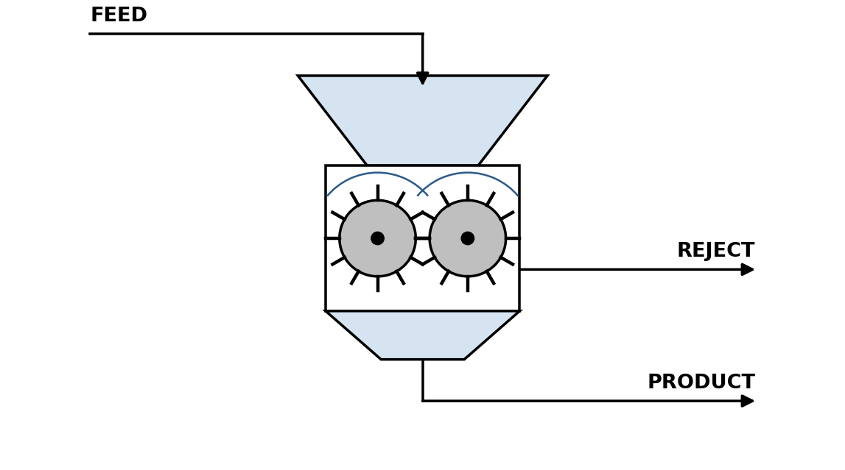
Unit Specific Parameters
$η_{SHR}$: mass fraction of the feed passed to product
$W_{SHR}^{sp}$: specific power of the shredder (kW per kg/h)
Variables
$Q_{SHR}^{S}$: Capacity (kg/h)
$PW_{SHR}$: operating power (kW)
Equations
Product stream:
 | $$M_{4,k}=η_{SHR}M_{3,k} ;∀k∈K$$ | (29)
Reject stream:
 | $$M_{5,k}=\left(1-η_{SHR}\right)M_{3,k} ;∀k∈K$$ | (30)
Capacity:
 | QSHRS=k∈K​M3,k | (31)
Power required:
 | $$PW_{SHR}=W_{SHR}^{sp}Q_{SHR}^{S}$$ | (32)
Macerator (MCR)
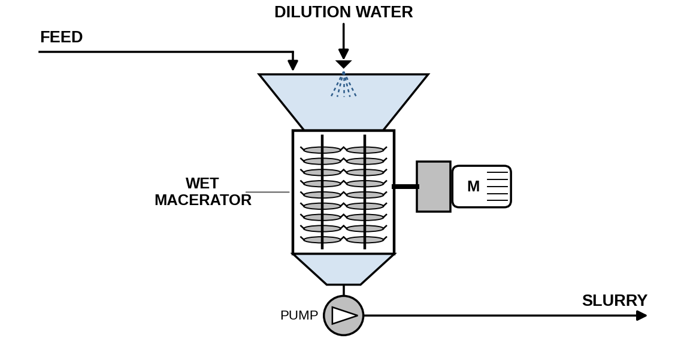
Unit Specific Parameters
${TS}_{MCR}$: target total solids fraction of the pumpable slurry
$W_{MCR}^{sp}$: specific power of the macerator (kW per kg/h)
Variables
$M_{7,WATER}$: dilution water added (kg/h)
$Q_{MCR}^{S}$: capacity (kg/h)
$PW_{MCR}$: operating power (kW)
Equations
Dry solids entering the macerator:
 | MDS,MCR=k∈K,k≠WATER​M6,k | (33)
Dilution water to reach the target solids content:
 | $$M_{7,WATER}=\left(\frac{1}{{TS}_{MCR}}-1\right)M_{DS,MCR}-M_{6,WATER}$$ | (34)
Slurry stream:
 | $$M_{8,k}=M_{6,k}+M_{7,k} ;∀k∈K$$ | (35)
Capacity:
 | QMCRS=k∈K​M6,k | (36)
Power required:
 | $$PW_{MCR}=W_{MCR}^{sp}Q_{MCR}^{S}$$ | (37)
Aerobic Pretreatment (AER)
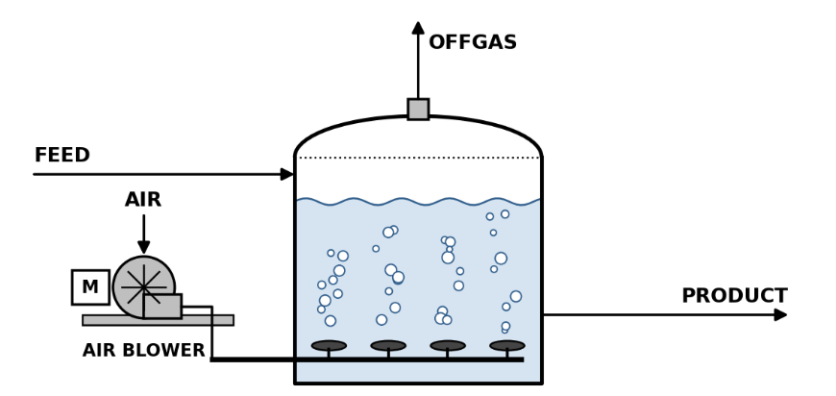
$f_{deg}^{AER}$: fraction of volatile solids degraded
$EAR^{AER}$: excess air ratio
$y_{O2}$, $y_{N2}$: O₂ and N₂ mass fractions of air
$Y_{O2}^{AER}$, $Y_{CO2}^{AER}$: O₂ demand and CO₂ yield per kg VS degraded, calculated from the elemental composition of the feed (kg/kg VS)
$ρ_{s}$, $ρ_{w}$: solids and water densities (kg/m³)
$θ^{AER}:$ residence time (h)
$ϵ^{AER}$: working volume fraction
$W_{AER}^{sp}$: specific mixing power (kW/m³)
Variables
$VS_{deg}^{AER}:$ volatile solids degraded (kg/h)
$O_{2}^{AER}$: oxygen consumed (kg/h)
$V_{w}^{AER}$, $V^{AER}$: working and vessel volumes (m³)
$Q_{AER}^{S}$: vessel volume used for costing (m³)
$PW_{AER}$: operating power (kW)
Equations
Volatile solids degraded:
 | VSdegAER=k∈KVS​fdegAERM10,k | (38)
Oxygen consumed:
 | $$O_{2}^{AER}=Y_{O2}^{AER} VS_{deg}^{AER}$$ | (39)
Aeration air:
 | $$M_{13,O2}=EAR^{AER}O_{2}^{AER}$$ | (40a)
 | $$M_{13,N2}=\frac{y_{N2}}{y_{O2}}M_{13,O2}$$ | (41b)
Undegraded organics in product stream:
 | $$M_{12,k}=\left(1-f_{deg}^{AER}\right)M_{10,k} ;∀k∈K^{VS}$$ | (42)
Off-gas CO₂, O₂ and N₂:
 | $$M_{11,CO2}=Y_{CO2}^{AER}VS_{deg}^{AER}$$ | (43a)
 | $$M_{11,O2}=M_{13,O2}-O_{2}^{AER}$$ | (43b)
 | $$M_{11,N2}=M_{13,N2}$$ | (43c)
Working volume:
 | VwAER=θAERk≠WATER​M10,kρs+M10,WATERρw | (44)
Vessel volume:
 | $$ϵ^{AER}V^{AER}=V_{w}^{AER}$$ | (45)
Capacity:

 | $$Q_{AER}^{S}=V^{AER}$$ | (46)
Power required:
 | $$PW_{AER}=W_{AER}^{sp}Q_{AER}^{S}$$ | (47)

Enzymatic Hydrolysis (ENZ)
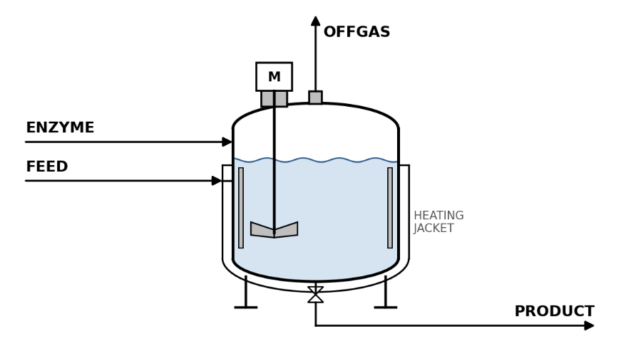
Unit Specific Parameters
$r_{ENZ}$: enzyme dose per kg dry solids (kg/kg)
$c_{p}$: heat capacity of the feed (kJ/(kg K))
$T_{ENZ}$, $T_{amb}$: hydrolysis and ambient temperatures (°C)
$Δh_{stm}$: latent heat of steam (kJ/kg)
$ρ_{s}$, $ρ_{w}$: solids and water densities (kg/m³)
$θ^{ENZ}$: hydraulic residence time (h)
$ϵ^{ENZ}$: working volume fraction
$W_{ENZ}^{sp}$: specific power (kW/m³)
$η^{AND}$: base AND volatile solids destruction
$δ^{ENZ}$: uplift of AND destruction when ENZ is upstream
Variables
$DS^{ENZ}$: dry solids entering (kg/h)
$V^{ENZ}$: vessel volume (m³)
$V_{w}^{ENZ}$: working volume (m³)
$H^{ENZ}$: heat duty (kJ/h)
$M_{ENZ}^{stm}$: steam demand (kg/h)
$Q_{ENZ}^{S}$: vessel volume used for costing (m³)
$PW_{ENZ}$: operating power (kW)
$η_{eff}^{AND}$: effective AND destruction efficiency
Equations
Dry solids entering:
 | DSENZ=k∈K,k≠WATER​M14,k | (348
Enzyme addition:
 | $$M_{15,ENZYME}=r_{ENZ}DS^{ENZ}$$ | (49)
Product stream:
 | $$M_{17,k}=M_{14,k}+1_{\left[k=PRT\right]} M_{15,ENZYME} ;∀k∈K,k≠ENZYME$$ | (50a)
where $1_{\left[k=PRT\right]}$ equals 1 for protein and 0 otherwise.
Off-gas stream:
 | $$M_{16,k}=0 ;∀k∈K$$ | (51)
Heat to raise the feed to the hydrolysis temperature:
 | HENZ=k∈K​M14,k+M15,ENZYMEcpTENZ-Tamb | (52)
Steam demand:
 | $$M_{ENZ}^{stm}=\frac{H^{ENZ}}{Δh_{stm}}$$ | (53)
Working volume:
 | VwENZ=θENZk∈K,k≠WATER​M14,k+M15,ENZYMEρs+M14,WATERρw | (54)
Vessel volume:
 | $$ϵ^{ENZ}V^{ENZ}=V_{w}^{ENZ}$$ | (55)
Capacity:
 | $$Q_{ENZ}^{S}=V^{ENZ}$$ | (56)
Power required:
 | $$PW_{ENZ}=W_{ENZ}^{sp}Q_{ENZ}^{S}$$ | (57)
Annual enzyme cost:
 | $$C_{ENZ}^{enz}=c^{enz}T^{ann}M_{15,ENZYME}×{10}^{-6}$$ | (58)
Effect on anaerobic digestion:
 | $$η_{eff}^{AND}=η^{AND}\left(1+δ^{ENZ}y_{ENZ}\right)$$ | (59)

Hydrothermal Liquefaction (HTL
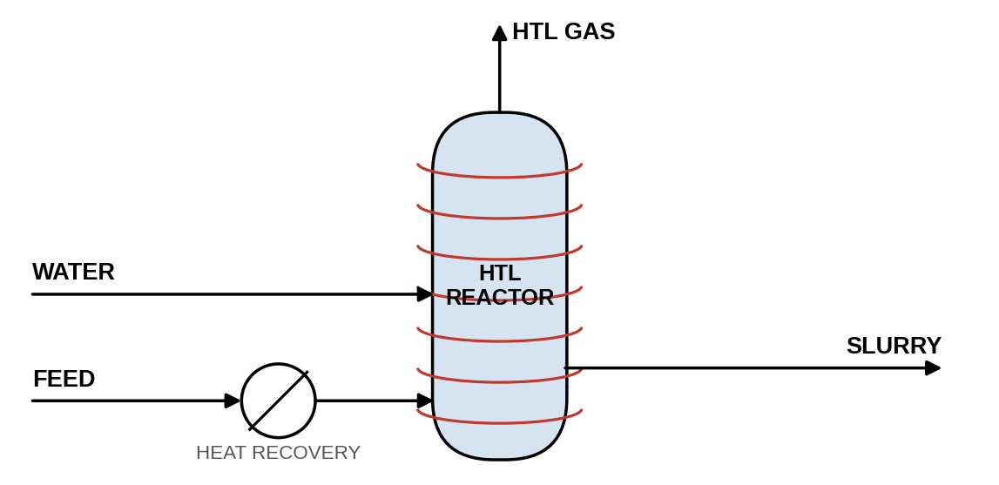
Unit Specific Parameters
$TS^{HTL}$: design solids content of the HTL feed
$Y_{k}^{HTL}$: yield of products(kg/kg dry ash-free organics)
$ρ^{HTL}$: feed slurry density at inlet conditions (kg/m³)
$θ^{HTL}:$ residence time (h)
$ϵ^{HTL}$: working volume fraction
$η^{HX}$: heat recovery
$Δh_{w}$: enthalpy rise of the feed from ambient to reaction temperature at reactor pressure (kJ/kg)
$HHV^{gas}:$ heating value of the HTL gas (MJ/kg)
$LHV_{NG}$: lower heating value of natural gas (MJ/kg)
$η_{fh}$: fired heater efficiency
$w_{N}$: nitrogen mass fraction of the feed (dry, ash free)
$ξ_{AQ}^{N}$: fraction of HTL feed nitrogen reporting to the aqueous phase
$W_{HTL}^{sp}$: specific power (kW/m³)
Variables
$M_{HTL}^{daf}$: dry ash-free organics entering (kg/h)
$m^{HTL}$: heated slurry mass (kg/h)
$V_{w}^{HTL}$, $V^{HTL}$: working and vessel volumes (m³)
$H_{net}^{HTL}$, $H_{gas}^{HTL}$: net heat duty and heat from burning the HTL gas (kJ/h)
$M_{HTL}^{NG}$: natural gas burned in the fired heater (kg/h)
$N^{AQ}:$ nitrogen to the aqueous phase (kg N/h)
$PW_{HTL}$: operating power (kW)
Equations
Dry ash-free organics:
 | MHTLdaf=k∈KVS​M19,k+M19,FC | (60)
Dilution water to the design solids content:
Water already present in the HTL feed + added water must be at least the water needed to reach the design solids content of the dry material entering HTL
 | M19,WATER+M21,WATER≥1TSHTL-1k≠WATER​M19,k | (61)
HTL gas Stream:
 | $$M_{20,GAS}=Y_{GAS}^{HTL}M_{HTL}^{daf}$$ | (62)
Biocrude stream:
 | $$M_{22,BIOCRUDE}=Y_{BIOCRUDE}^{HTL}M_{HTL}^{daf}$$ | (63)
Char Stream:
 | $$M_{22,CHAR}=Y_{CHAR}^{HTL}M_{HTL}^{daf}+M_{19,ASH}$$ | (64)
Aqueous phase:
 | $$M_{22,AQ}=Y_{AQ}^{HTL}M_{HTL}^{daf}+M_{19,WATER}+M_{21,WATER}$$ | (65)
Nitrogen to the aqueous phase:
 | $$N^{AQ}=w_{N}M_{HTL}^{daf} ξ_{AQ}^{N}$$ | (66)
Heated mass:
 | mHTL=k​M19,k+M21,WATER | (67)
Working volume:
 | $$ρ^{HTL}V_{w}^{HTL}=θ^{HTL}m^{HTL}$$ | (68)
Vessel volume:
 | $$ϵ^{HTL}V^{HTL}=V_{w}^{HTL}$$ | (69)
Capacity:
 | $$Q_{HTL}^{S}=V^{HTL}$$ | (70)
Power required:
 | $$PW_{HTL}=W_{HTL}^{sp}Q_{HTL}^{S}$$ | (71)

Net heat duty after heat recovery:
 | HnetHTL=1-ηHXk∈K​M19,k+M21,WATERΔhw | (72)
Heat from burning the HTL gas:
 | $$H_{gas}^{HTL}=1000 HHV^{gas}M_{20,GAS}$$ | (73)
Natural gas for the fired heater:
 | $$1000 LHV_{NG}η_{fh}M_{HTL}^{NG}≥H_{net}^{HTL}-H_{gas}^{HTL}$$ | (74)

Anaerobic Digestion (AD)
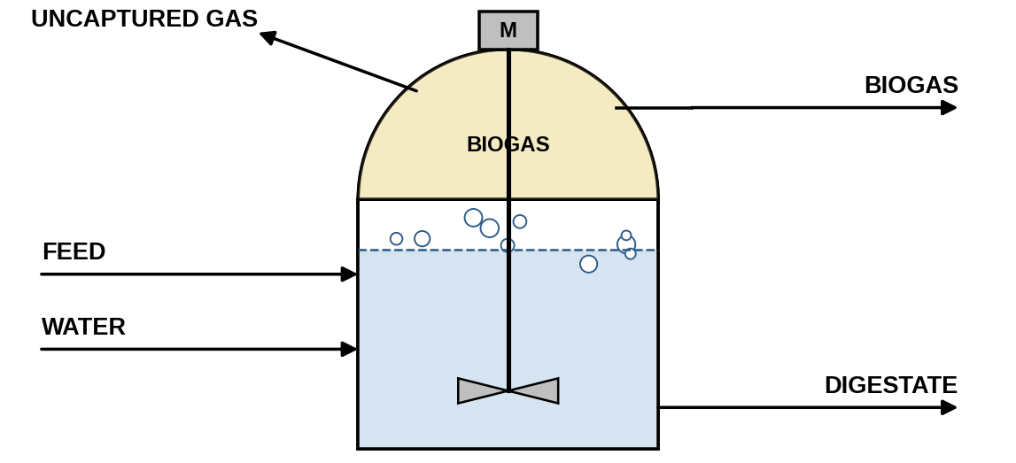
Unit Specific Parameters
$TS^{AND}$: design solids content of the digester feed
$η^{AND}$: volatile solids destruction
$η_{OTH}^{AND}$: fraction of other volatile organics (OTH) available for digestion
$Y_{g}^{AND}$: Buswell yield of g ∈ {CH4, CO2, NH3, H2S} and water consumed per kg VS destroyed, calculated from the elemental composition of the feed (kg/kg VS)
$η_{cap}^{AND}$: fraction of generated biogas captured
$θ^{AND}$: hydraulic residence time (h)
$ϵ^{AND}$: working volume fraction
$ρ_{s}$, $ρ_{w}$: solids and water densities (kg/m³)
$c_{p}$: heat capacity of the feed (kJ/(kg K))
$T_{AND}$, $T_{amb}$: digester and ambient temperatures (°C)
$Δh_{stm}$: latent heat of steam (kJ/kg)
$W_{AND}^{sp}$: specific mixing power (kW/m³)
Variables
$VS_{in}^{AND}$, $VS_{deg}^{AND}$: digestible volatile solids entering and destroyed (kg/h)
$G_{g}^{AND}$: mass of g generated (kg/h)
$η_{eff}^{AND}$: effective volatile solids destruction (Enzymatic Hydrolysis section)
$V_{w}^{AND}$, $V^{AND}$: working and vessel volumes (m³)
$Q_{AND}^{S}$: vessel volume used for costing (m³)
$M_{AND}^{stm}$: steam demand (kg/h)
$PW_{AND}$: operating power (kW)
Equations
Water added to achieve the design solids content:
 | M23,WATER+M24,WATER=1TSAD-1k≠WATER​M23,k | (75)
Volatile solids entering:
 | $$VS_{in}^{AD}=M_{23,CBH}+M_{23,PRT}+M_{23,FAT}+η_{OTH}^{AD}M_{23,OTH}$$ | (76)
Volatile solids destroyed:
 | $$VS_{deg}^{AD}=η_{eff}^{AD}VS_{in}^{AD}$$ | (77)
Buswell based gas generation:
 | $$G_{g}^{AD}=Y_{g}^{AD}VS_{deg}^{AD} ;g∈\{CH4,CO2,NH3,H2S,H2O\}$$ | (78)
Captured biogas:
 | $$M_{27,g}=η_{cap}^{AD}G_{g}^{AD} ;g∈\{CH4,CO2,NH3,H2S,H2O\}$$ | (79)
Uncaptured gas:
 | $$M_{25,g}=\left(1-η_{cap}^{AD}\right)G_{g}^{AD} ;g∈\{CH4,CO2,NH3,H2S,H2O\}$$ | (80)
Digestate, undegraded organics:
 | $$M_{26,k}=\left(1-η_{eff}^{AD}\right)M_{23,k} ;k∈K_{VS}$$ | (81)
Digestate, ash, and fixed carbon:
 | $$M_{26,k}=M_{23,k} ;k∈\{ASH,FC\}$$ | (82)
Working volume:
 | VwAND=θANDk≠WATER​M23,kρs+M23,WATER+M24,WATERρw | (83)
Vessel volume:
 | $$ϵ^{AND}V^{AND}=V_{w}^{AND}$$ | (84)
Capacity:
 | $$Q_{AND}^{S}=V^{AND}$$ | (85)

Steam to heat the feed to digester temperature:
 | MANDstm=k∈K​M23,k+M24,WATERcpTAND-TambΔhstm | (86)
Power required:
 | $$PW_{AD}=W_{AD}^{sp}Q_{AND}^{S}$$ | (87)
Sanitary Landfill (SLF)
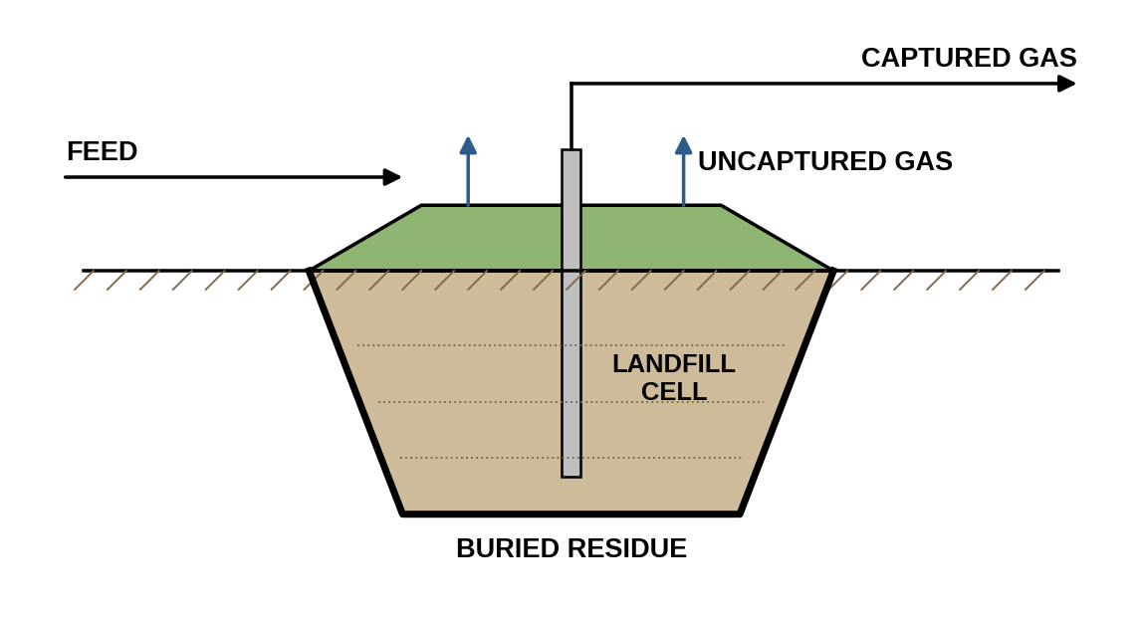
Unit Specific Parameters
$DOC$, $DOC_{f}$: degradable organic carbon and fraction dissimilated (IPCC 2006)
$MCF$: methane correction factor
$F$: CH₄ volume fraction of landfill gas
$γ_{CH4/C}$: CH₄ to carbon mass ratio (kg/kg)
$MW_{CO2}$, $MW_{CH4}$: molecular weights (kg/kmol)
$CAP$, $OX$: gas capture and cover oxidation
$T_{ann}$: operating hours (h/yr)
$ρ_{FW}$: food waste solids density (kg/m³)
$D^{SLF}$: landfill depth (m)
$A_{acre}$: area conversion (m²/acre)
$W_{SLF}^{sp}$ : specific power (kW/acre)
Variables
$G_{CH4}^{SLF}$, $G_{CO2}^{SLF}$: landfill gas generation (kg/h)
$G_{ox}^{SLF}$: methane oxidized in the cover (kg/h)
$m_{left}^{SLF}$: permanently buried residue (kg/h)
$V^{SLF}$: annual landfill volume (m³/yr)
$Q_{SLF}^{S}$: new land required (acre/yr)
$PW_{SLF}$: operating power (kW)
Equations
Methane generated:
 | GCH4SLF=DOC DOCf MCF F γCH4/Ck∉{WATER,ASH}​M28,k | (67)
Carbon dioxide generated:
 | $$G_{CO2}^{SLF}=G_{CH4}^{SLF}(\frac{1-F}{F})\frac{MW_{CO2}}{MW_{CH4}}$$ | (68)
Methane oxidized in the cover:
 | $$G_{ox}^{SLF}=\left(1-CAP\right)OXG_{CH4}^{SLF}$$ | (69)
Captured gas stream:
 | $$M_{30,g}=CAPG_{g}^{SLF} ;g∈\{CH4,CO2\}$$ | (70)
Uncaptured methane stream :
 | $$M_{29,CH4}=\left(1-CAP\right)\left(1-OX\right)G_{CH4}^{SLF}$$ | (71)
Uncaptured carbon dioxide stream:
 | $$M_{29,CO2}=\left(1-CAP\right)G_{CO2}^{SLF}+\frac{MW_{CO2}}{MW_{CH4}}G_{ox}^{SLF}$$ | (72)
Residue(Wasteleft):
 | mleftSLF=k​M28,k-g∈{CH4,CO2}​M29,g+M30,g | (73)
Annual landfill volume:
 | VSLF=Tannk​M28,kρFW | (74)
Land required:
 | $$Q_{SLF}^{S} D^{SLF} A_{acre}=V^{SLF}$$ | (75)
Power required:
 | $$PW_{SLF}=W_{SLF}^{sp}Q_{SLF}^{S}$$ | (76)
Composting (CMP)
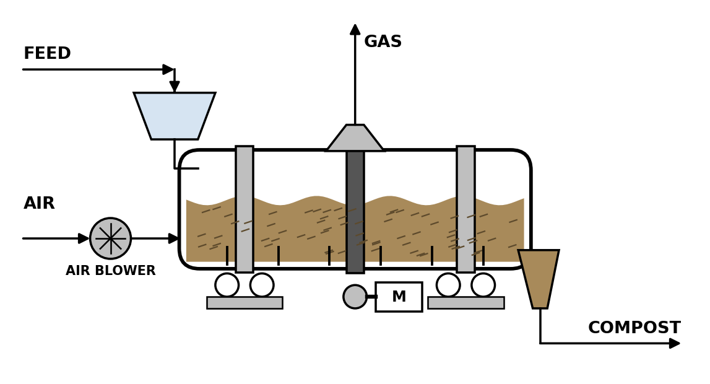
Unit Specific Parameters
$η_{OTH}^{CMP}$: share of OTH counted as degradable
$f_{deg}^{CMP}$: fraction of VS degraded
$α_{O2}^{CMP}$: oxygen demand per VS degraded(kg O₂/kg VS)
$EAR^{CMP}$: excess air ratio
$y_{O2}$, $y_{N2}$: O₂ and N₂ mass fractions of air
$Y_{g}^{CMP}$: CO₂, H₂O and NH₃ yields per kg of VS degraded plus O₂ consumed (kg/kg)
$EF_{CH4}^{CMP}$, $EF_{N2O}^{CMP}$: CH₄ and N₂O emission factors (kg/kg VS)
$θ^{CMP}$: residence time (h)
$ρ_{FW}$: food waste solids density (kg/m³)
$ϵ^{CMP}$: working volume fraction
$W_{CMP}^{sp}$: specific power (kW/m³)
Variables
$VS_{in}^{CMP}$, $VS_{deg}^{CMP}$: volatile solids entering and degraded (kg/h)
$O_{2}^{CMP}$: oxygen consumed (kg/h)
$A^{CMP}$: aeration air (kg/h)
$V_{w}^{CMP}$, $V^{CMP}$: working and vessel volumes (m³)
$M_{CMP,COMPOST}^{P}$: saleable compost (dry basis) (kg/h)
$PW_{CMP}$: operating power (kW)
Equations
Volatile solids entering:
 | $$VS_{in}^{CMP}=M_{31,CBH}+M_{31,PRT}+M_{31,FAT}+η_{OTH}^{CMP}M_{31,OTH}$$ | (77)
Volatile solids degraded:
 | $$VS_{deg}^{CMP}=f_{deg}^{CMP}VS_{in}^{CMP}$$ | (78)
Oxygen demand:
 | $$O_{2}^{CMP}=α_{O2}^{CMP}VS_{deg}^{CMP}$$ | (79)
Aeration air:
 | $$A^{CMP}≥\frac{EAR^{CMP}O_{2}^{CMP}}{y_{O2}}$$  $$M_{33,O2}=y_{O2}A^{CMP}$$  $$M_{33,N2}=y_{N2}A^{CMP}$$ | (80)
Process gas stream :
 | $$M_{32,g}=Y_{g}^{CMP}\left(VS_{deg}^{CMP}+O_{2}^{CMP}\right) ;g∈\{CO2,WATER,NH3\}$$ | (81)
Fugitive CH₄ and N₂O:
 | $$M_{32,CH4}=EF_{CH4}^{CMP}VS_{in}^{CMP}$$  $$M_{32,N2O}=EF_{N2O}^{CMP}VS_{in}^{CMP}$$ | (82)
Residual air:
 | $$M_{32,O2}=M_{33,O2}-O_{2}^{CMP},$$  $$M_{32,N2}=M_{33,N2}$$ | (83)
Compost organics Stream :
 | $$M_{34,k}=\left(1-f_{deg}^{CMP}\right)M_{31,k} ;k∈\{CBH,PRT,FAT\}$$ | (84)
Compost OTH:
 | $$M_{34,OTH}=\left(1-f_{deg}^{CMP}η_{OTH}^{CMP}\right)M_{31,OTH}$$ | (85)
Compost inerts and water:
 | $$M_{34,k}=M_{31,k} ;k∈\{WATER,ASH,FC\}$$ | (86)
Saleable compost (dry basis):
 | MCMP,COMPOSTP=k∈K​M34,k | (87)
Working volume:
 | VwCMP=θCMPk​M31,kρFW | (88)
Vessel volume:
 | $$ϵ^{CMP}V^{CMP}=V_{w}^{CMP}$$ | (89)
Capacity:
 | $$Q_{CMP}^{S}=V^{CMP}$$ | (89)
Power required:
 | $$PW_{CMP}=W_{CMP}^{sp}Q_{CMP}^{S}$$ | (90)

Wastewater Treatment (WWT)
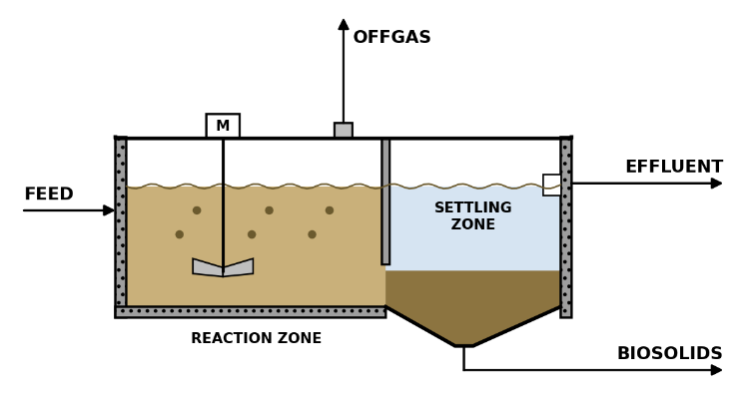
Unit Specific Parameters
$ρ_{ww}$: wastewater density (kg/m³)
$f_{BOD}$: BOD per kg VS (kg/kg)
$Y_{X}$: biomass yield (kg/kg)
$b$: endogenous decay rate (1/d)
$SRT$: solids retention time (d)
$r_{k}^{WWT}$: fraction of component k reporting to sludge
$w_{N}$: nitrogen mass fraction of the feed
$Y_{CO2}^{WWT}$, $Y_{H2O}^{WWT}$: CO₂ and H₂O yields per VS degraded (kg/kg)
$EF_{CH4}^{WWT}$, $EF_{N2O}^{WWT}$: CH₄ and N₂O emission factors (kg/kg VS)
$F/M$: food to microorganism loading (1/d)
$X_{MLSS}$: mixed liquor suspended solids (kg/m³)
$W_{WWT}^{sp}$: specific power (kW/m³)
Variables
$Q^{WWT}:$ wastewater flow (m³/h)
$VS_{in}^{WWT}$, $VS_{deg}^{WWT}$: volatile solids entering and degraded (kg/h)
$P_{X}$: net biosolids yield (kg/h)
$N^{EFF}$: nitrogen leaving in the effluent (kg N/h)
$m_{left}^{WWT}$: treated effluent (kg/h)
$Q_{WWT}^{S}$: aeration tank volume (m³)
$PW_{WWT}$: operating power (kW)
Equations
Wastewater flow:
 | QWWT=k​M35,kρww | (91)
Volatile solids entering:
 | VSinWWT=k∈KVS​M35,k | (92)
Volatile solids degraded:
 | $$VS_{deg}^{WWT}=f_{BOD}VS_{in}^{WWT}-\frac{Y_{X}f_{BOD}VS_{in}^{WWT}}{1+bSRT}$$ | (93)
Sludge split stream:
 | $$M_{37,k}=r_{k}^{WWT}M_{35,k} ;∀k∈K$$ | (94)
Net biosolids yield:
 | $$P_{X}=\frac{Y_{X}f_{BOD}VS_{in}^{WWT}}{1+bSRT}+M_{37,ASH}+M_{37,FC}$$ | (95)
Nitrogen to effluent:
 | $$N^{EFF}=w_{N}VS_{in}^{WWT}\left(1-r_{PRT}^{WWT}\right)$$ | (96)
Off-gas CO₂ and water (stream 36):
 | $$M_{36,CO2}=Y_{CO2}^{WWT}VS_{deg}^{WWT}$$  $$M_{36,WATER}=Y_{H2O}^{WWT}VS_{deg}^{WWT}$$ | (97)
Off-gas CH₄ and N₂O:
 | $$M_{36,CH4}=EF_{CH4}^{WWT}VS_{in}^{WWT}$$  $$M_{36,N2O}=EF_{N2O}^{WWT}VS_{in}^{WWT}$$ | (98)
Treated effluent:
 | mleftWWT=k​M35,k-k​M37,k-k​M36,k | (99)
Aeration tank volume (F/M basis):
 | $$Q_{WWT}^{S}=\frac{24 f_{BOD}VS_{in}^{WWT}}{F/M X_{MLSS}}$$ | (100)
Power required:
 | $$PW_{WWT}=W_{WWT}^{sp}Q_{WWT}^{S}$$ | (101)
Saleable biosolids:
 | $$M_{WWT,BIOSOLIDS}^{P}=P_{X}$$ | (102)
Incineration (INC)
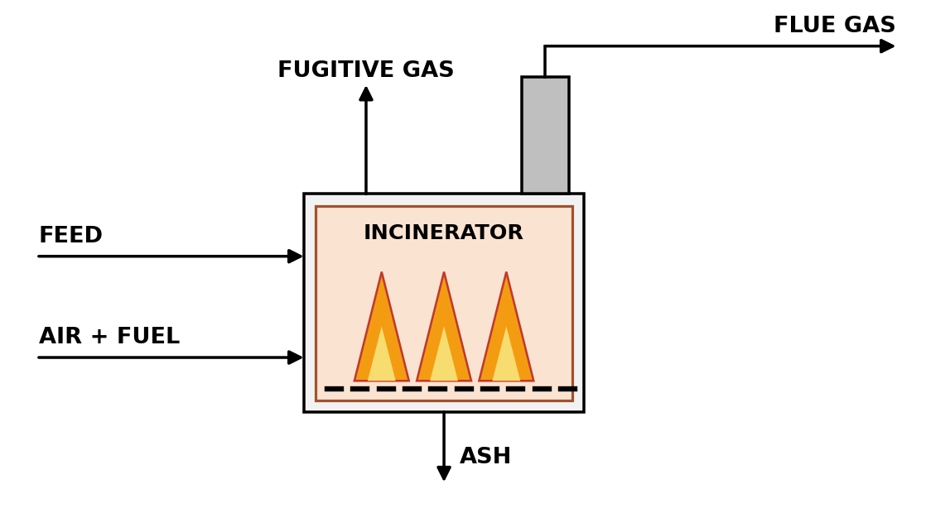
Unit Specific Parameters
$w_{e}$: ultimate analysis, e ∈ {C, H, O, N, S}
$MW_{e}$: atomic weights (kg/kmol)
$HHV$: feed higher heating value (MJ/kg dry)
$h_{fg}$: latent heat of water (MJ/kg)
$LHV^{self}:$ self-sustaining combustion threshold (MJ/kg wet)
$LHV^{NG}$, $MW_{NG}$: natural gas heating value and molecular weight (MJ/kg, kg/kmol)
$EF^{NG}$: fossil CO₂ from natural gas combustion (kg CO₂/kg)
$λ^{INC}$: excess air ratio
$EF_{CH4}^{INC}$, $EF_{N2O}^{INC}$, $EF_{NOx}^{INC}$: fugitive emission factors (kg/kg wet feed)
$W_{INC}^{sp}$: specific power (kW per kg/h)
Variables
$m_{dry}^{INC}$, $m_{ash}^{INC}$, $m_{daf}^{INC}$: dry, ash and dry ash-free feed (kg/h)
$n_{e}$: elemental molar flows(kmol/h)
$LHV^{INC}$: wet feed lower heating value (MJ/kg)
$m^{NG}$, $n_{NG}$: auxiliary natural gas (kg/h, kmol/h)
$CO_{2}^{foss}$: fossil CO₂ (kg/h)
$n_{O2}^{sto}$, $n_{O2}^{in}$, $n_{N2}^{air}$: stoichiometric O₂, supplied O₂ and air N₂ (kmol/h)
$NO_{x}$: NOₓ emitted (kg/h)
$m^{flue}$: flue gas mass (kg/h)
$PW_{INC}$: operating power (kW)
Equations
Dry, ash and dry ash-free feed:
 | mdryINC=k​M38,k-M38,WATER  $$m_{daf}^{INC}=m_{dry}^{INC}-m_{ash}^{INC}$$ | (103)
Elemental molar flows:
 | $$n_{e}=\frac{m_{daf}^{INC} w_{e}}{MW_{e}} ;e∈\{C,H,O,N,S\}$$ | (104)
Wet feed lower heating value:
 | LHVINCk​M38,k=HHV mdryINC-hfgM38,WATER | (105)
Fuel to reach the self-sustaining threshold:
 | mNG LHVNG≥LHVself-LHVINCk​M38,k | (106)
Natural gas moles and fossil CO₂:
 | $$n_{NG}=\frac{m^{NG}}{MW_{NG}}, CO_{2}^{foss}=EF^{NG}m^{NG}$$ | (107)
Stoichiometric oxygen:
 | $$n_{O2}^{sto}=n_{C}+0.25n_{H}+n_{S}-0.5n_{O}+2n_{NG}$$ | (108)
Combustion air:
 | $$n_{O2}^{in}=λ^{INC}n_{O2}^{sto}$$  $$n_{N2}^{air}=\frac{0.79}{0.21}n_{O2}^{in}$$ | (109)
Combustion products:
 | $$n_{CO2}=n_{C}+n_{NG}, n_{H2O}=0.5n_{H}+2n_{NG}$$  $$n_{SO2}=n_{S}$$ | (110)
Excess oxygen and nitrogen:
 | $$n_{O2}^{out}=n_{O2}^{in}-n_{O2}^{sto}$$  $$n_{N2}^{out}=n_{N2}^{air}+0.5n_{N}$$ | (111)
Fugitive emissions (stream 39):
 | M39,CH4=EFCH4INCk​M38,k  M39,N2O=EFN2OINCk​M38,k | (112)
NOₓ emitted:
 | NOx=EFNOxINCk​M38,k | (113)
Flue gas CO₂, water and SO₂ stream:
 | $$M_{40,CO2}=44.01 n_{CO2}$$  $$M_{40,WATER}=M_{38,WATER}+18.015 n_{H2O}$$  $$M_{40,SO2}=64.06 n_{SO2}$$ | (114)
Flue gas O₂ and N₂:
 | $$M_{40,O2}=32.00 n_{O2}^{out}$$  $$M_{40,N2}=28.0134 n_{N2}^{out}$$ | (115)
Flue gas mass:
 | mflue=k​M40,k | (116)
Capacity:
 | QINCS=k​M38,k | (117)
Power required:
 | $$PW_{INC}=W_{INC}^{sp}Q_{INC}^{S}$$ | (117)
Centrifuge (CEN)
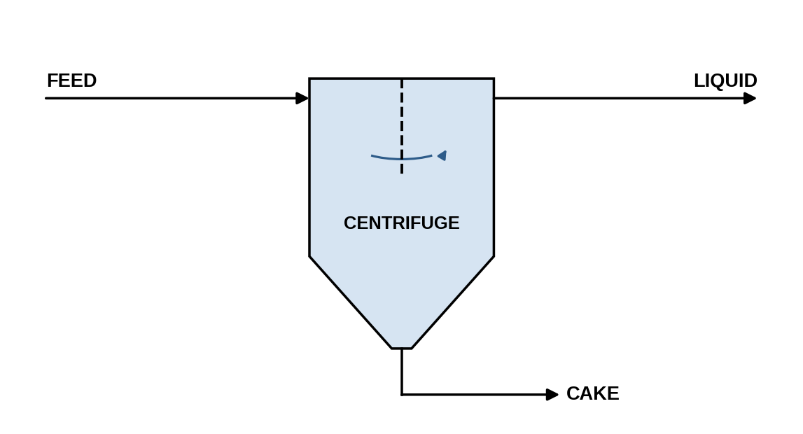
Unit Specific Parameters
$η^{CEN}$: separation efficiency
$ρ_{k}$: density of HTL product
$W_{CEN}^{sp}$: specific power (kW per m³/h)
$C_{p,w}$: heat capacity of cooling water (kJ/(kg K))
$T_{in}^{cw}$, $T_{out}^{cw}$: cooling water supply and return temperatures (°C)
Variables
$CF_{CEN}$: volumetric concentration factor
$U_{CEN}$: sigma factor
$Q_{CEN}^{S}$: equivalent settling area (sigma) (m²)
$PW_{CEN}$: operating power (kW)
$M_{CEN}^{CW}$ : cooling water (kg/h)
Equations
Component balance:
 | $$M_{41,k}=M_{42,k}+M_{43,k} ;∀k∈K$$ | (118)
Liquid product stream:
 | $$M_{43,k}=η^{CEN}M_{41,k} ;∀k∈K$$ | (119)
Char cake stream:
 | $$M_{42,CHAR}=η^{CEN}M_{41,CHAR}$$ | (120)
Concentration factor:
 | CFCENM42,CHARρCHAR=k∈KHTL​M41,kρk | (121)
Sigma factor:
 | QCENSUCEN=k∈KHTL​M41,kρk | (122)
Power required:
 | PWCEN=WCENspk∈KHTL​M41,kρk | (123)
Power dissipated as heat is about 40%, so cooling duty is required:
 | $$M_{CEN}^{CW}C_{p,w}\left(T_{out}^{cw}-T_{in}^{cw}\right)=0.4×3600 PW_{CEN}$$ | (124)
Filtration (FLT)
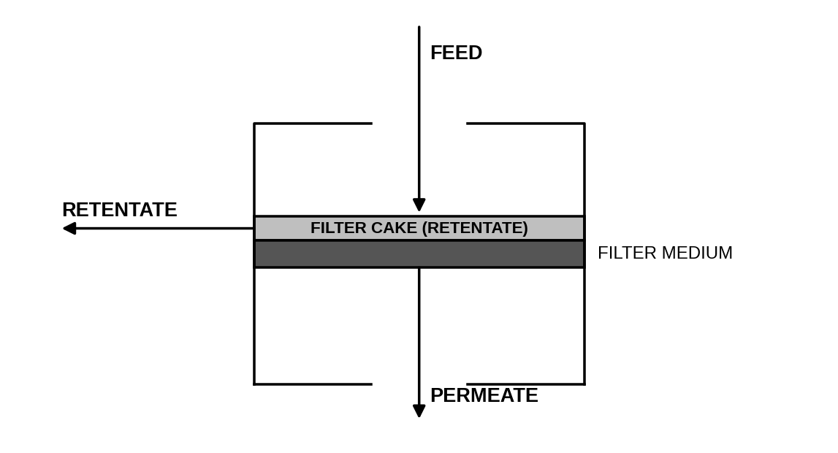
Unit Specific Parameters
$R_{k}^{FLT}$: fraction of HTL product k retained by the filter
$ρ_{k}$: density of HTL product k (kg/m³)
$ζ^{FLT}$: permeate flux (m³/(h m²))
$W_{FLT}^{sp}$; specific power (kW/m²)
Variables
$CF_{FLT}$: volumetric concentration factor
$Q_{FLT}^{S}$: filter area (m²)
$PW_{FLT}$: operating power (kW)
Equations
Retentate (stream 45):
 | $$M_{45,k}=R_{k}^{FLT}M_{44,k} ;∀k∈K^{HTL}$$ | (125)
Permeate (stream 46):
 | $$M_{46,k}=\left(1-R_{k}^{FLT}\right)M_{44,k} ;∀k∈K^{HTL}$$ | (126)
Concentration factor:
 | CFFLTk∈KHTL​M45,kρk=k∈KHTL​M44,kρk | (127)
Flux balance:
 | ζFLTQFLTSCFFLT=k∈KHTL​M44,kρkCFFLT-1 | (128)
Power required:
 | $$PW_{FLT}=W_{FLT}^{sp}Q_{FLT}^{S}$$ | (129)
Absorption (ABS)
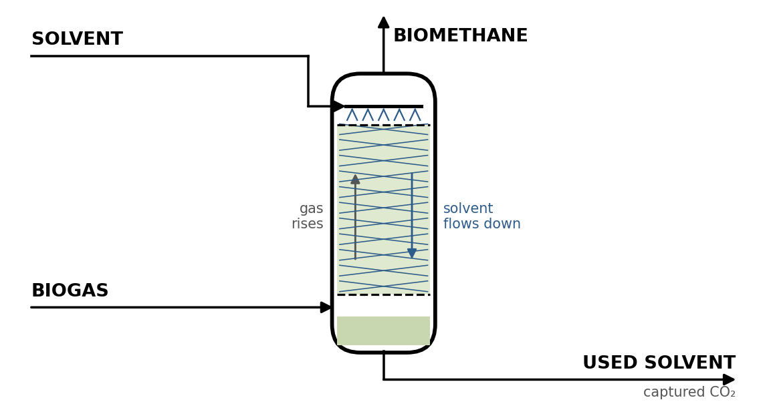
Unit Specific Parameters
$s_{CH4}^{ABS}$: CH₄ slip to offgas
$η_{CO2}^{ABS}$: CO₂ removal
$V_{m}$: molar volume at STP (m³/kmol)
$MW_{CH4}$, $MW_{CO2}$: molecular weights (kg/kmol)
$e^{ABS}$: electricity per Nm³ of biogas (kWh/Nm³)
$x^{pur}$: required CH₄ purity (mol/mol)
$r_{w}^{ABS}$: wash water per kg CO₂ removed (kg/kg CO₂)
$s^{stm}$: amine regeneration steam per Nm³ of biogas (kg/Nm³)
Variables
$Q_{ABS}^{S}$: biogas flow treated (Nm³/h)
$PW_{ABS}$: operating power (kW)
$M_{ABS}^{STM}$: regeneration steam (kg/h)
Equations
Biomethane product stream:
 | $$M_{52,CH4}=\left(1-s_{CH4}^{ABS}\right)M_{49,CH4}, M_{52,CO2}=\left(1-η_{CO2}^{ABS}\right)M_{49,CO2}$$ | (130)
Off-gas stream:
 | $$M_{51,CH4}=s_{CH4}^{ABS}M_{49,CH4}, M_{51,CO2}=η_{CO2}^{ABS}M_{49,CO2}$$ | (131)
Wash water stream:
 | $$M_{50,WATER}=r_{w}^{ABS}η_{CO2}^{ABS}M_{49,CO2}$$ | (132)
Biogas flow at STP:
 | $$Q_{ABS}^{S}=V_{m}\left(\frac{M_{49,CH4}}{MW_{CH4}}+\frac{M_{49,CO2}}{MW_{CO2}}\right)$$ | (133)
Power required:
 | $$PW_{ABS}=e^{ABS}Q_{ABS}^{S}$$ | (134)
Regeneration steam:
 | $$M_{ABS}^{STM}=s^{stm}Q_{ABS}^{S}$$ | (135)
Product purity:
 | $$\left(1-x^{pur}\right)\frac{M_{52,CH4}}{MW_{CH4}}≥x^{pur}\frac{M_{52,CO2}}{MW_{CO2}}$$ | (136)
Saleable biomethane:
 | $$M_{ABS,CH4}^{P}=M_{52,CH4}$$ | (137)
Pressure Swing Adsorption (PSA)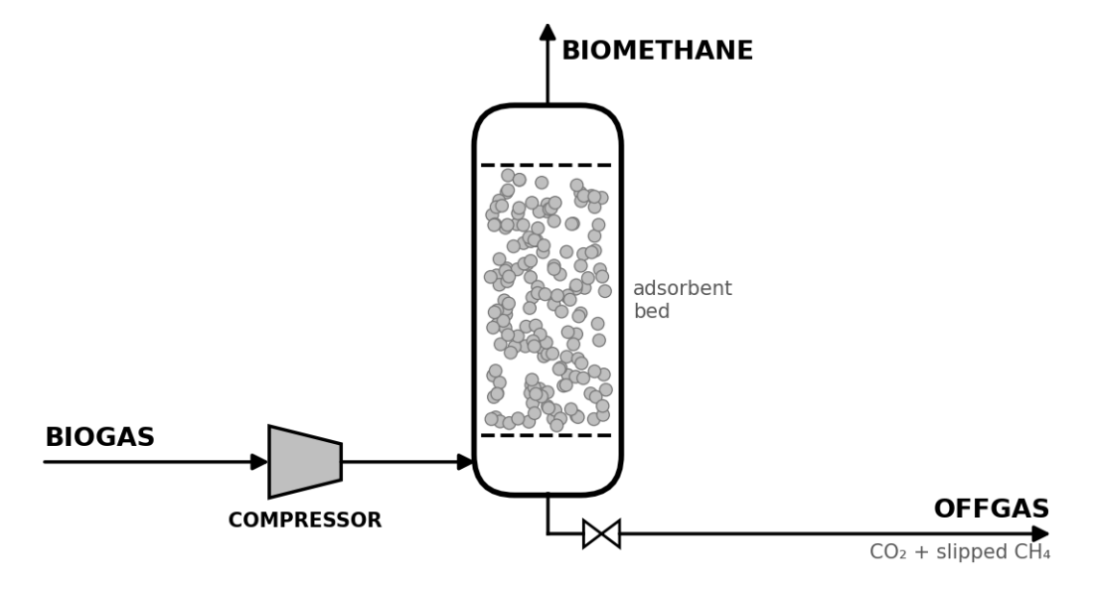
Unit Specific Parameters
$s_{CH4}^{PSA}$: CH₄ slip to purge
$η_{CO2}^{PSA}$: CO₂ removal
$V_{m}$: molar volume at STP (m³/kmol)
$MW_{CH4}$, $MW_{CO2}$: molecular weights (kg/kmol)
$e^{PSA}$: electricity per Nm³ of biogas (kWh/Nm³)
$x^{pur}$: required CH₄ purity (mol/mol)
Variables
$Q_{PSA}^{S}$: biogas flow treated (Nm³/h)
$PW_{PSA}$: operating power (kW)
Equations
Biomethane product stream:
 | $$M_{55,CH4}=\left(1-s_{CH4}^{PSA}\right)M_{53,CH4}$$  $$M_{55,CO2}=\left(1-η_{CO2}^{PSA}\right)M_{53,CO2}$$ | (138)
Off-gas stream:
 | $$M_{54,CH4}=s_{CH4}^{PSA}M_{53,CH4}, M_{54,CO2}=η_{CO2}^{PSA}M_{53,CO2}$$ | (139)
Biogas flow at STP:
 | $$Q_{PSA}^{S}=V_{m}\left(\frac{M_{53,CH4}}{MW_{CH4}}+\frac{M_{53,CO2}}{MW_{CO2}}\right)$$ | (140)
Power required:
 | $$PW_{PSA}=e^{PSA}Q_{PSA}^{S}$$ | (141)
Product purity:
 | $$\left(1-x^{pur}\right)\frac{M_{55,CH4}}{MW_{CH4}}≥x^{pur}\frac{M_{55,CO2}}{MW_{CO2}}$$ | (142)
Saleable biomethane:
 | $$M_{PSA,CH4}^{P}=M_{55,CH4}$$ | (143)
Steam Turbine (STB)
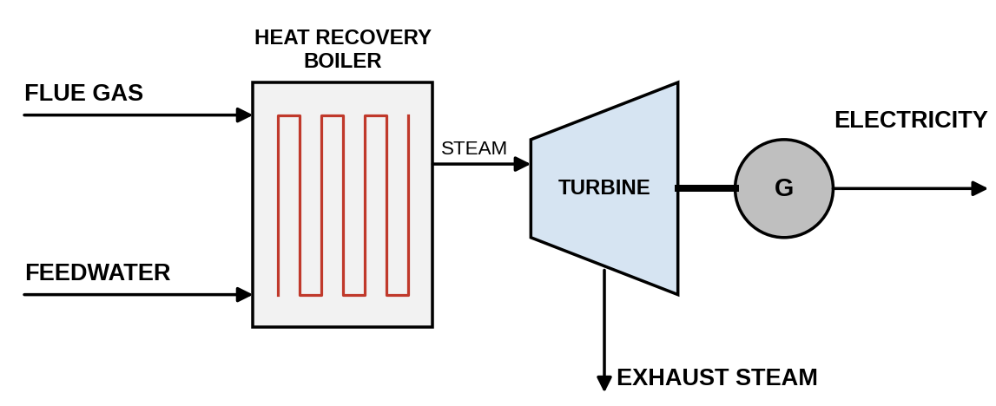

Unit Specific Parameters
$C_{p,g}$: flue gas heat capacity (kJ/(kg K))
$T_{in}^{g}$, $T_{out}^{g}$: flue gas inlet and outlet temperatures (°C)
$H_{1}$, $H_{2}$: feedwater and steam enthalpies (kJ/kg)
$h_{1}$, $h_{2}$: turbine inlet and outlet enthalpies (kJ/kg)
$η_{t}$, $η_{g}$: turbine and generator efficiencies
$W_{STB}^{sp}$: specific parasitic power (kW/kW)
Variables
$M_{59,WATER}$: boiler feedwater raised to steam (kg/h)
$P^{turb}$: turbine shaft work (kJ/h)
$Q_{STB}^{S}$: net electricity generated (kW)
$PW_{STB}$: power (kW)
Equations
Heat recovery from the flue gas:
 | $$m^{flue}C_{p,g}\left(T_{in}^{g}-T_{out}^{g}\right)=M_{59,WATER}\left(H_{2}-H_{1}\right)$$ | (144)
Steam raised (stream 60):
 | $$M_{60,WATER}=M_{59,WATER}$$ | (145)
Turbine shaft work:
 | $$P^{turb}=M_{60,WATER}\left(h_{1}-h_{2}\right)$$ | (146)
Electricity generated:
 | $$Q_{STB}^{S}=\frac{η_{t}η_{g}P^{turb}}{3600}$$ | (147)
Power required:
 | $$PW_{STB}=W_{STB}^{sp}Q_{STB}^{S}$$ | (148)
Saleable electricity (stream 57):
 | $$M_{57,ELECTRICITY}=M_{STB,ELECTRICITY}^{P}=Q_{STB}^{S}$$ | (149)

S3. Costing
S3.1. Cost Variables
$C^{CAP}$ - Annualized capital cost (CCAC), M$/yr
$C^{WC}$ - Annualized working capital (CCWC), M$/yr
$C^{INS}$ - Insurance and property tax (CCINS), M$/yr
$C^{LBR}$ - Labor cost (CCLB), M$/yr
$C^{UTL}$ - Utility cost (CCUC), M$/yr
$C^{FAC}$ - Facility-dependent cost: maintenance, overhead and local taxes (CCOC), M$/yr
$C^{RM}$ - Raw material cost (CCRM), M$/yr
$C^{DSP}$ - Disposal cost (CDISP), M$/yr
$C^{TIP}$ - Tipping fee received (CTIP), M$/yr
$C^{TC}$ - Total annual cost (CCTC), M$/yr
Rev - Annual revenue, product sales plus tipping fee (REV), M$/yr

S3.2. Cost Equations
Purchase cost for technology i
 | $$C_{i}^{PC}=C_{i}^{0}\left[{\left(\frac{Q_{i}^{C}}{Q_{i}^{0}}\right)}^{n_{c}}\right] ;i∈I$$ | (150)
where $C_{i}^{0}$ and $Q_{i}^{0}$ are the reference cost and capacity and $n_{c}$ the six-tenths scaling exponent
Annualized capital,
 | CCAP=CRF FBMi​CiPC106 | (151)
working capital,
 | CWC=rWCCRF FBMi​CiPC106 | (152)
insurance
 | CINS=rINSFBMi​CiPC106 | (153)
facility-dependent cost
 | CFAC=rFACFBMi​CiPC106 | (154)
Labor cost
 | $$N_{i}^{LB}Q_{i}^{0}=N_{i}^{r}Q_{i}^{C} ;i∈I$$  CLBR=cLB Tanni​NiLB106 | (155)
Utility cost
 | CUTL=Tann106i​celPWi+cstmMiSTM+ccwMiCW | (156)
Raw material cost
 | $$C^{RM}=\frac{T_{ann}}{{10}^{6}}(c^{w}\left(M_{7,W}+M_{21,W}+M_{24,W}+M_{59,W}\right)$$  $$+c^{enz}M_{15,ENZYME}+c^{am}λ^{am}M_{50,W}+c^{NG}m^{NG})$$ | (157)
Disposal cost
 | CDSP=Tann106(crejk​M5,k+ccharM42,CHAR+M45,CHAR | (158)
$$+c^{aq}\left(M_{42,AQ}+M_{45,AQ}+M_{50,W}\right)$$
+clandk​M28,k+mleftWWT+mashINC)
Tipping fee
 | CTIP=ctip Tann106k​M1,k | (159)
Revenue
 | $$Rev=\frac{T_{ann}}{{10}^{6}}(p_{CH4}M_{56,CH4}+p_{BIO}M_{47,BIOCRUDE}+p_{CMP}M_{CMP,COMPOST}^{P}$$  $$+p_{BS}P_{X}+p_{EL}Q_{STB}^{S})+C^{TIP}$$ | (160)
Total annual cost
 | $$C^{TC}=C^{CAP}+C^{WC}+C^{INS}+C^{UTL}+C^{LBR}+C^{FAC}+C^{RM}+C^{DSP}$$ | (161)
Net annual cost
 | $NAC=C^{TC}-R$ev | (162)
where $CRF$ is the capital recovery factor, $F_{BM}$ the bare-module multiplier, $r$ the working capital, insurance and facility cost ratios, $c$ the unit costs and $p$ the product prices (Tables S2.6 and S2.7). Digestate is land applied and carries no disposal cost.

S4. Environmental impact equations
Indirect emissions from electricity and steam
 | GHGIND=Tann1000EFeli​PWi+EFstmi​MiSTM | (163)
Direct emissions
 | $$GHG^{DIR}=\frac{T_{ann}}{1000}\left(E_{CH4}+E_{N2O}+CO_{2}^{foss}+E_{HTL}\right)$$  $$E_{CH4}=GWP_{CH4}\left(M_{25,CH4}+M_{29,CH4}+M_{32,CH4}+M_{36,CH4}+M_{39,CH4}\right)$$  $$E_{N2O}=GWP_{N2O}\left(M_{32,N2O}+M_{36,N2O}+M_{39,N2O}\right)$$  $$E_{HTL}=\left(EF^{HTLgas}+GWP_{CH4}ϕ^{vent}w_{CH4}^{gas}\right)M_{20,GAS}$$ | (164)
Displacement credits
 | $$GHG^{CR}=\frac{T_{ann}}{1000}(EF_{CH4}^{d}M_{56,CH4}+EF_{BIO}^{d}M_{47,BIOCRUDE}$$  $$+EF_{CMP}^{d}M_{CMP,COMPOST}^{P}+EF_{BS}^{d}P_{X}+EF_{EL}^{d}Q_{STB}^{S})$$ | (165)
HTL residue burdens and digestate credit
 | $$GHG^{AQ}=\frac{T_{ann}}{1000}\left[EF^{aq}\left(M_{42,AQ}+M_{45,AQ}\right)+EF^{char}\left(M_{42,CHAR}+M_{45,CHAR}\right)\right]$$  GHGDIG=Tann1000 EFdigk≠WATER​M26,k | (166)
Net greenhouse gas emissions
 | $$GHG^{TOT}=GHG^{IND}+GHG^{DIR}+GHG^{AQ}-GHG^{CR}-GHG^{DIG}$$ | (167)
Marine eutrophication potential
 | EPMAR=Tann1000NAQ+NEFF+u∈{CMP,AD,SLF}​λuleachwNk∈KVS​Mju,k+CFNOxNOx | (168)
where $j\left(u\right)$ is the stream carrying the residue that leaches: 34 (compost), 26 (digestate) and 28 (landfilled feed). The emission factors are listed in Table S4.1-B. $ϕ^{vent}$ is the fraction of HTL gas assumed vented and $w_{CH4}^{gas}$ its CH₄ mass fraction. The $EP^{MAR}$ characterization factor is 1 kg N-eq per kg N for nitrogen to water.

S5. Model parameters
Table S1-3 lists the measured analyses and the wet-basis component fractions used in the feed equation. Table S2.4 lists the feed dependent yields computed from these analyses.
Table S1: Proximate analysis of food waste feed.
Property | Value | Basis
Moisture | 75.95 | % wet
Volatile matter | 80.23 | % dry
Ash | 5.17 | % dry
Fixed carbon | 14.60 | % dry
Table S2: Biochemical composition of food waste feed.
Property | Value | Basis
Carbohydrate | 6.95 | % dry
Protein | 44.82 | % dry
Lipid | 19.28 | % dry
Table S3: Ultimate analysis of food waste feed.
Property | Value | Basis
Carbon | 43.27 | % wet
Hydrogen | 6.05 | % dry
Nitrogen | 7.17 | % dry
Oxygen | 42.89 | % dry
Sulfur | 0.62 | % dry

Table S4: Feed-dependent yields computed in the feed characterization
Quantity | Symbol | Value | Unit
Buswell AD yield, CH₄ | $$Y_{CH4}^{AD}$$ | 0.2703 | kg/kg VS destroyed
Buswell AD yield, CO₂ | $$Y_{CO2}^{AD}$$ | 0.8441 | kg/kg VS destroyed
Buswell AD yield, NH₃ | $$Y_{NH3}^{AD}$$ | 0.0872 | kg/kg VS destroyed
Buswell AD yield, H₂S | $$Y_{H2S}^{AD}$$ | 0.0066 | kg/kg VS destroyed
Water consumed by hydrolysis | $$Y_{H2O}^{AD}$$ | 0.2081 | kg/kg VS destroyed
HTL biocrude, | $$Y_{BIO}^{HTL}$$ | 0.3523 | kg/kg organics
HTL char, | $$Y_{CHAR}^{HTL}$$ | 0.1023 | kg/kg organics
HTL gas, | $$Y_{GAS}^{HTL}$$ | 0.1479 | kg/kg organics
HTL aqueous phase, by difference | $$Y_{AQ}^{HTL}$$ | 0.3974 | kg/kg organics

Buswell yields use the feed formula $C_{1}H_{h}O_{o}N_{n}S_{s}$ from the ultimate analysis. The HTL yields depend on $z$, the dry-basis protein plus lipid fraction ($z=0.641$ for the feed basis). The linear yield coefficients were calibrated so that a 50/50 feed reproduces biocrude, char, aqueous and gas yields of 0.35, 0.10, 0.40 and 0.15.
Table S5: Capital cost, power and labor correlation data by technology
Technology | $C_{i}^{0}$ ($) | $$Q_{i}^{0}$$ | Capacity unit | $W_{i}^{sp}$ (kW/unit) | $N_{i}^{r}$ (operators)
SHR | 111,000 | 10,000 | kg/h | 0.02 | 0.1
MCR | 111,000 | 60,000 | kg/h | 0.10 | 0.1
AER | 882,000 | 15,000 | m³ | 0.04 | 0.5
ENZ | 882,000 | 15,000 | m³ | 0.04 | 0.5
HTL | 645,000 | 40 | m³ | 2.0 | 2.0
AD | 594,000 | 1,000 | m³ | 0.005 | 0.02
SLF | 450,000 | 0.15 | acre | 0.5 | 1.0
CMP | 786,000 | 350 | m³ | 0.02 | 0.5
WWT | 8,000,000 | 15,000 | m³ | 0.04 | 0.5
INC | 4,700,000 | 8,000 | kg/h | 0.05 | 1.0
CEN | 66,000 | 0.01 | m² (sigma) | 0.1 | 1.0
FLT | 39,000 | 80 | m² | 0.1 | 0.5
ABS | 30,000 | 32 | Nm³/h | 0.1 | 0.01
PSA | 80,000 | 50 | Nm³/h | 0.4 | 0.01
STB | 45,000 | 30,000 | kW | 0.02 | 0.05

